PRN: 20190802077

**LAB-3**

AIM:

Write a program to create a binary search tree and display the in-order walk of the tree. Also find the max and min depth of the and the lowest common ancestor of the BST by taking the inputs from the user. Implement heap sort and compute the time and memory taken by different number of inputs.

EXPERIMENT:

In-order Traversal of a tree: In this traversal the left sub-tree is visited first, then the root and later the right sub-tree. In-order traversal of a BST will produce sorted key values in ascending order.

The maximum depth of a binary tree is the number of nodes from the root down to the furthest leaf node. The minimum depth of a binary tree is the number of nodes from the root node to the nearest leaf node.

Lowest Common Ancestor: Let T be a rooted tree then the lowest common ancestor (LCA) between two nodes n1 and n2 is defined as the lowest node in T that has both n1 and n2.

Heap Sort: Heap sort is a comparison-based sorting technique based on Binary Heap data structure. A [Binary Heap](https://www.geeksforgeeks.org/binary-heap/) is a complete binary tree where items are stored in a special order such that value in a parent node is greater or smaller than the values in its two children nodes. The former is called as max heap and the latter is called min-heap.

**Heap Sort Algorithm for sorting in increasing order:**  
**1.** Build a max heap from the input data.  
**2.** At this point, the largest item is stored at the root of the heap. Replace it with the last item of the heap followed by reducing the size of heap by 1and then heapify the root of the tree.

**3.** Repeat the second step while size of heap is greater than 1.

OUTPUT:

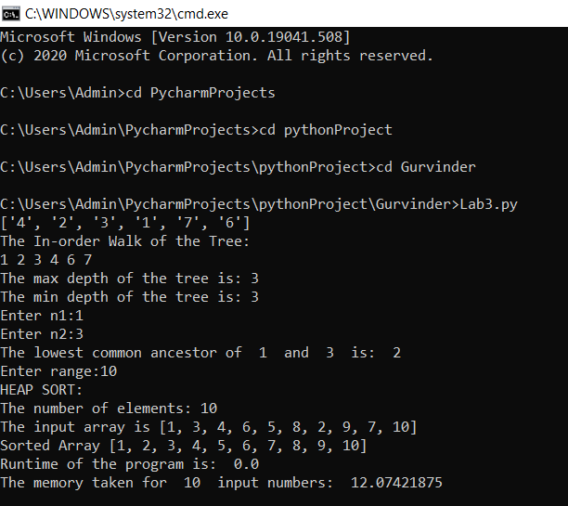

Time and Memory taken for different number of inputs:

|  |  |  |
| --- | --- | --- |
| n | Heap Sort (Time taken) | Heap Sort (Memory taken) |
| 10 | 0 | 12.07421875 |
| 100 | 0.001002788544 | 12.15234375 |
| 500 | 0.004610300064 | 12.16015625 |
| 1000 | 0.005009174347 | 12.171875 |
| 10000 | 0.09461903572 | 12.34375 |

CONCLUSION:

A binary search tree is created and the in-order walk of the tree is displayed. The maximum and minimum depth was computed and displayed. The lowest common ancestor was also computed by taking inputs from the user. Heap sort was performed for different number of inputs and the time taken and memory taken was computed for each case.